**CHAPTER-1**

**INTRODUCTION**

* 1. B**ackground**

A college “campus recruitment system” that consists of a student login, company login and an admin login. The project is beneficial for college students, various companies visiting the campus for recruitment and even the college placement officer. The software system allows the students to create their profiles and upload all their details including their marks onto the system. The admin can check each student details and can remove faulty accounts. The system also consists of a company login where various companies visiting the college can view a list of students in that college and also their respective resumes. The software system allows students to view a list of companies who have posted for vacancy. The admin has overall rights over the system and can moderate and delete any details not pertaining to college placement rules. The system handles student as well as company data and efficiently displays all this data to respective sides.

**1.2Objective**

The main aim of this project is to establish an online campus recruitment system which will be helpful for both company and student.

The meaning of education has changed today. Today people need education to get a job in a good company. In this competitive environment only college level knowledge is not enough to get a good job. Now a day’s students are doing so many extra courses with their main primary course. Students have to really struggle and work hard to get a job in their dream company. Students are joining various job oriented skill based training programs to win the competition and get a place in a multinational company. Even some colleges are conducting placement training program in the college campus itself, because getting a job through college campus is must easier than getting a job through off campus. But this recruitment and selection process might be very complicated task for both college and company if not carried out properly. After doing so much hard work a deserving candidate might not get job if recruitment process is not proper and it is not acceptable. Even for company it is very important to select the best candidate available in the market, as the development of an organization is directly related with the efficiency of its employee.

By keeping these points in mind we have develop this online recruitment system, which is very helpful for both the company and student. Here company gets a chance to select the best candidate available, also its helps deserving students to get their desire job in their dream company.

This worthy and heirloom project is developed using PHP and SQL.

**1.3 Purpose and Scope**

**1.3.1 Purpose**

• The Website is for the automation of campus Recruitment.

• It maintains three levels of users:-

* + - * Administrator Level
      * Student Level
      * Company level

• The Software includes:-

* Maintaining Student details.
* Providing view for particular job profile.
* Providing both student details and company details.
* Providing view for particular student.

**1.3.2 Scope**

It can be used in any Campus for maintaining student details and company details.

**CHAPTER-2**

**SURVEY OF TECHNOLOGIES**

**Introduction to PHP:**

PHP sits between your browser and the web server. When you type in the URL of a PHP website in your browser, your browser sends out a request to the web server. The web server then calls the PHP script on

**PHP Process Diagram**

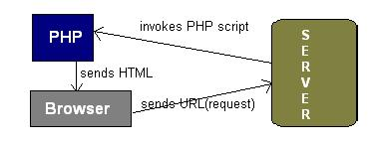

PHP is a server-side, cross-platform, HTML-embedded scripting language. There are over half a million domains running PHP and it is freely available for download. Much of PHP’ syntax is borrowed from C, Java and Perl with a couple of unique PHP-specific features thrown in. The goal of the language is to allow web developers to write dynamically generated pages quickly. PHP eliminates the need for numerous small cgi programs by allowing you to place simplescripts directly in your HTML files.

It also makes it easier to manage large web sites by placing all components of a web page in a single html file. PHP is an excellent alternative to such similar programming solutions as Microsoft's proprietary scripting engine ASP and Allier’s rather expensive ColdFusion. As mentioned before, PHP is a cross-platform language. This doesn't stop with the core PHP code but can be extended to all of PHP's libraries and all code written in PHP. Neither ASP nor ColdFusion can make this claim. PHP has a large feature set which includes built-in support for numerous databases (*including Access, LDAP, Oracle, and MSSQL*), networking support, zip archiving, and an excellent set of built-in functions. Furthermore, due in part to it being open source and freely available for download on the web, the language enjoys an active developing environment. Since the syntax structure borrows heavily from C, it is easy for even the novice programmer to learn the language. PHP is also the oldest HTML-embedded scripting language, giving it a head start on all the others. If you are a content developer, you probably won’t want to learn PHP scripting by heart.

But, it is nice to know how PHP can help you create more powerful web applications and user-friendly designs.

**FRONT END USED**

**Hyper Text Markup Language (HTML):-**

HTML, or Hyper Text Markup Language, has two essential features hypertext and universality. Hypertext means you can create a link in a Web page that leads the visitor to any other Web page or to practically anything else on the Internet. It means that the information on the Web can be accessed from many different directions. Tim Berners-Lee, the creator of the Web, wanted it to work more like a person's brain and less like a static source of data, such as a book.

Universality means that because HTML documents are saved as Text Only files, virtually any computer can read a Web page. It doesn't matter if your visitors have Macintosh or Windows machines, or whether they're on a Unix box or even a handheld device like a Palm. The Web is open to all.

**Hyper Text Markup Language (HTML 5):-**

Html5 was developed to solve compatibility problem that effect the current standard HTML-4 one of the biggest differences between html5 and previous version is that older version require proprietary plugins and API’s (This is why a web page that was built and tested in one browser may not load correctly in another browser).HTML5 provides one common interface to make loading elements easier.

One of the design goals for HTML5 to support multimedia on mobile devices. New syntactic features were introduced to support such as video, audio, and canvas tags.

**Cascading Style Sheet (CSS):-**

Cascading Style Sheets (CSS) are a powerful way to affect the presentation of a document or a collection of documents. Obviously, CSS is basically useless without a document of some sort, since it would have no content to present. Of course, the definition of "document" is extremely broad. For example, Mozilla and related browsers use CSS to affect the presentation of the browser chrome itself. Still, without the content of the chrome buttons, address inputs, dialog boxes, windows, and so on there would be no need for CSS (or any other presentational information).

It is possible to completely change the way elements are presented by a user agent. This can be executed at a basic level with the display property, and in a different way by associating style sheets with a document. The user will never know whether this is done via an external or embedded style sheet, or even with an inline style. The real importance of external style sheets is the way in which they allow authors to put all of a site's presentation information in one place, and point all of the documents to that place. This not only makes site updates and maintenance a breeze, but it helps to save bandwidth since all of the presentation is removed from documents.

To make the most of the power of CSS, authors need to know how to associate a set of styles with the elements in a document. To fully understand how CSS can do all of this, authors need a firm grasp of the way CSS selects pieces of a document for styling, which is the subject of the next chapter.

**BACK END USED**

* **MYSQL**

My SQL, the most popular Open Source SQL database management system, is developed, distributed, and supported by Oracle Corporation.

* **MySQL is a database management system.**

A database is a structured collection of data. It may be anything from a simple shopping list to a picture gallery or the vast amounts of information in a corporate network. To add, access, and process data stored in a computer database, you need a database management system such as MySQL Server. Since computers are very good at handling large amounts of data, database management systems play a central role in computing, as standalone utilities, or as parts of other applications.

* **My SQL databases are relational.**

A relational database stores data in separate tables rather than putting all the data in one big storeroom. The database structures are organized into physical files optimized for speed. The logical model, with objects such as databases, tables, views, rows, and columns, offers a flexible programming environment. You set up rules governing the relationships between different data fields, such as one-to-one, one-to-many, unique, required or optional, and “pointers” between different tables. The database enforces these rules, so that with a well-designed database, your application never sees inconsistent, duplicate, orphan, out-of-date, or missing data.

The SQL part of “My SQL” stands for “Structured Query Language”. SQL is the most common standardized language used to access databases. Depending on your programming environment, you might enter SQL directly (for example, to generate reports), embed SQL statements into code written in another language, or use a language-specific API that hides the SQL syntax.

SQL is defined by the ANSI/ISO SQL Standard. The SQL standard has been evolving since 1986

and several versions exist. In this manual, “SQL-92” refers to the standard released in 1992, “SQL:1999” refers to the standard released in 1999, and “SQL:2003” refers to the current version of the standard. We use the phrase “the SQL standard” to mean the current version of the SQL Standard at any time.

* **My SQL software is Open Source.**

Open Source means that it is possible for anyone to use and modify the software. Anybody can download the My SQL software from the Internet and use it without paying anything. If you wish, you may study the source code and change it to suit your needs.

* **The MySQL Database Server is very fast, reliable, scalable, and easy to use.**

If that is what you are looking for, you should give it a try. My SQL Server can run comfortably on a desktop or laptop, alongside your other applications, web servers, and so on, requiring little or no attention. If you dedicate an entire machine to My SQL, you can adjust the settings to take advantage of all the memory, CPU power, and I/O capacity available. MySQL can also scale up to clusters of machines, networked together. My SQL Server was originally developed to handle large databases much faster than existing solutions and has been successfully used in highly demanding production environments for several years. Although under constant development, My SQL Server today offers a rich and useful set of functions. Its connectivity, speed, and security make My SQL Server highly suited for accessing databases on the Internet.

* **My SQL Server works in client/server or embedded systems.**

The My SQL Database Software is a client/server system that consists of a multi-threaded SQL server that supports different backend, several different client programs and libraries, administrative tools, and a wide range of application programming interfaces (APIs). We also provide MySQL Server as an embedded multi-threaded library that you can link into your application to get a smaller, faster, easier-to-manage standalone product.

* **A large amount of contributed MySQL software is available.**

MySQL Server has a practical set of features developed in close cooperation with our users. It is very likely that your favorite application or language supports the MySQL Database Server.

**CHAPTER-3**

**REQUIREMENT AND ANALYSIS**

**3.1 Problem Definition**

Problems with conventional system

1**. Lack of immediate information storage**: - The information generated by various transactions takes time and efforts to be stored at right place.

2. **Lack of prompt updating**: - Various changes to information like student details or company details difficult to make as paper work is involved.

3**. Preparation of accurate and prompt reports**: - This becomes a difficult task as information is difficult to collect from various registers.

**3.2 Requirement Specification**

* It provides a platform to pick the best candidates for different job profiles. Besides getting a wider choice, the employers also save a lot of time in recruitment. Most of the young job seekers are talented and ready to accept challenges. Students also get the option to choose and screen their employers this way, according to their skills and interests. It also saves them a lot of time and frustration involved with job hunting.
* Campus recruitment is an extremely cost efficient activity as it saves a lot of time for the employers. The recruitment team needs to visit a few colleges and spend just one or two days in a college to end up short-listing hundreds of candidates. If they have a hiring calendar, it can be an extremely cost-efficient activity for future hiring. The other way round is to go to different places and incur huge expense in traveling, advertisements, screening, conducting the final round and finally getting a suitable candidate. Therefore, campus recruitment is time saving as well.
* The organizations conducting campus recruitment in a particular institute/college establish strong relationships with the concerned institute and its students. The students keep coming to these organizations for summer training and internships, etc. So, it builds a strong pipeline for next year’s recruitment. It is therefore the preferred activity of the employers.
* The selection ratio is much higher in campus recruitment as compared to other forms of recruitment activities.
* The other big advantage of campus recruitment is the loyalty factor. The young graduates have high regards for their first company as they are emotionally attached to it. Being their first employer, you are very close to their hearts and appear on top of their resume as well.

**3.3 Hardware and Software Requirements**

|  |  |  |
| --- | --- | --- |
| **Hardware Requirements** | | |
| **Processor** | **Hard-disk** | **Memory** |
| I3 | 50 GB | 1 GB |
| **Software Requirements** | | |
| **Operating System** | **Database** | **Software** |
| Windows latest version or old version | MySQL | Notepad++, Dreamweaver cs6, wampserver |

**3.4 Concept Models**

**DATA FLOW DIAGRAM**

A data flow diagram (DFD) is a graphical representation of the “flow” of data through an information system. DFDs can be used for the visualization of data processing (structured design). On a DFD, data items flow from an external data source or an internal data store to an internal data store or an external data sink, via an internal process.

A DFD provides no information about the timing or ordering of processes, or about processes will operate in sequence or in parallel. It is therefore quite different from a flowchart, which shows the flow of control through an algorithm, allowing a reader to determine what operations will be performed, in what order, and under what circumstances, but not what kinds of data will be input to and output from the system, nor where the data will come from and go to, nor where the data will be stored.

Student

Figure:- DFD 0 Level

Company

Student

Admin

Company

View Details

Upload Information

View Job

Fig. –DFD 1 Level DFD

E-R Diagram

**Student**

**Company**

Login

Has

Register

Goto

View

**Admin**

Delete

Has

Upload Information

Goto

CHAPTER-4

SYSTEM DESIGN

**4.1 Basic Modules**

**Company**:

First Company has to register to the portal. After registration company can post list of vacancies available in the organization where students can apply directly. Company can view list of candidates’ information those who have already applied for a particular position. Also company can search list of candidates based on various streams. If company finds any suitable candidate for a particular position they can directly send an interview call letter to that particular candidate.

**Student**:

Student can register to the portal by providing his required information. After registration student can view list of vacancies posted by various companies. If he is eligible for any position he can apply directly to that particular position by uploading all the relevant documents. Even student can search list of vacancies based on the criteria of salary.

**Admin**:

Admin is responsible for overall functionality of the portal. Admin can view list of companies and students registered to the portal. Admin can delete or modify any post posted by any company. Even admin has the privilege to delete any company or students from the portal.

**Source Coding**

**Index.html**

<!DOCTYPE...>

<html>

<title>www.crs.com</title>

<head>

<link rel="stylesheet" href="home.css">

</head>

<body>

<div id="main">

<div id="top">

</div>

<div id="menu">

<div id="hom">

<a href="index.html">HOME</a>

</div>

<div id="abt">

<a href="about.html">ABOUT US</a>

</div>

<div id="cnt">

<a href="contact.html">CONTACT US</a>

</div>

</div>

<div id="mid">

<img src="image/ss.PNG" width="750px" height="500px">

<div id="welcom">

<img src="image/welcom.png">

</div>

<div id="login">

<span class="sst"><center>LOGIN PAGE</center></span>

</div>

<div id="com">

<a href="complogin.html">Company</a>

</div>

<div id="stu">

<a href="stulogin.html">Student</a>

</div>

<div id="adm">

<a href="admlogin.html">Admin</a>

</div>

</div>

<div id="bottom">

<div id="bottom1">

<table>

<tr>

<td><a href="index.html" class="bot">

HOME</a>&nbsp;|</td>

<td><a href="about.html" class="bot">

ABOUT US</a>&nbsp;|</td>

<td><a href="contact.html" class="bot">

CONTACT</a>&nbsp;|</td>

</tr>

</table>

</div>

<div id="bottom2">

<span class="bot2">Design By :</span><span class="bot3"> Mr. Shyam Sundar Pradhan, Mr. Shiv Shankar Pradhan, & Mr. Prakash Oraon.</span>

</div>

</div>

</div>

</body>

</html>

**Home.css**

@charset "utf-8";

body

{

background-color:#666;

}

#main

{

position:absolute;

height:900px;

width:1000px;

left:175px;

right:175px;

top:50px;

bottom:0px;

border-radius:30px;

}

#top

{

position:absolute;

height:260px;

width:1000px;

left:0px;

right:0px;

top:30px;

bottom:610px;

background-image:url(image/cr1.jpg);

border-top-right-radius:30px;

border-top-left-radius:30px;

}

#menu

{

position:absolute;

height:500px;

top:300px;

bottom:100px;

width:250px;

left:0px;

right:750px;

background-color:#93C;

}

#menu a

{

position:absolute;

text-decoration:none;

color:#F00;

font-size:20px;

}

#menu a:hover

{

position:absolute;

text-decoration:none;

color:#FFF;

font-size:20px;

}

#hom

{

position:absolute;

height:40px;

top:100px;

bottom:360px;

width:70px;

left:90px;

right:90px;

text-shadow:3px 3px 10px #FF0;

}

#abt

{

position:absolute;

height:40px;

top:180px;

bottom:280px;

width:100px;

left:75px;

right:75px;

text-shadow:3px 3px 10px #FF0;

}

#cnt

{

position:absolute;

height:40px;

top:260px;

bottom:200px;

width:130px;

left:60px;

right:60px;

text-shadow:3px 3px 10px #FF0;

}

#bottom

{

position:absolute;

height:100px;

top:800px;

bottom:0px;

width:1000px;

left:0px;

right:0px;

background-color:#666;

}

#bottom1

{

position:absolute;

height:30px;

width:230px;

left:0px;

right:770px;

top:70px;

bottom:opx;

}

#bottom2

{

position:absolute;

height:30px;

width:700px;

left:0px;

right:300px;

top:10px;

bottom:6opx;

}

.bot2

{

font-size:25px;

color:#CC6;

}

.bot3

{

color:#CC6;

}

.bot

{

text-decoration:none;

font-size:10px;

color:#FFF;

}

#mid

{

position:absolute;

height:500px;

top:300px;

bottom:100px;

left:250px;

width:750px;

right:0px;

}

#mid a

{

position:absolute;

text-decoration:none;

font-size:28px;

color:#FFF;

text-align:center;

margin-top:25px;

margin-left:55px;

}

#mid a:hover

{

position:absolute;

text-decoration:none;

font-size:30px;

color:#900;

text-align:center;

margin-top:25px;

margin-left:55px;

}

#welcom

{

position:absolute;

height:100px;

width:750px;

left:0px;

right:0px;

top:0px;

bottom:400px;

}

#login

{

position:absolute;

height:40px;

top:120px;

bottom:340px;

width:300px;

left:225px;

right:225px;

background-image:url(image/ss1.PNG);

border-bottom-right-radius:50px;

border-top-left-radius:50px;

}

#com

{

position:absolute;

height:80px;

top:200px;

bottom:120px;

left:90px;

width:200px;

right:460px;

box-shadow:5px 5px 10px #FF0000;

border-radius:20px;

}

#stu

{

position:absolute;

height:80px;

top:200px;

bottom:120px;

width:200px;

right:90px;

left:460px;

box-shadow:5px 5px 10px #FF0000;

border-radius:20px;

}

#adm

{

position:absolute;

height:80px;

bottom:80px;

top:340px;

width:200px;

left:275px;

right:275px;

box-shadow:5px 5px 10px #FF0000;

border-radius:20px;

}

.sst

{

color:#FF0;

font-size:34px;

}

.welcom

{

color:#FFF;

font-size:24px;

}

**admlogin.html**

<!DOCTYPE...>

<html>

<title>www.crs.com</title>

<head>

<link rel="stylesheet" href="login.css">

</head>

<body>

<div id="main">

<div id="top">

</div>

<div id="mid">

<div id="mid1">

<center>

<h1><strong style="color: #FFFFFF">ADMIN LOGIN</strong></h1>

</center>

</div>

<div id="mid2">

<table width="750" height="200">

<form name="f" id="f" method="post" action="admlog_action.php">

<tr>

<th>Username* : <input type="text" placeholder="Admin Username" name="t1" required></th>

</tr>

<tr>

<th>Password* : <input type="password" placeholder="Admin Password" name="t2" required></th>

</tr>

<tr>

<th><input type="submit" value="Login">

&nbsp;<input type="reset" value="Reset"></th>

</tr>

<tr>

<th>New Admin<a href="admregister.php">Registered Now</a></th>

</tr>

</form>

</table>

</div>

</div>

<div id="menu">

<div id="hom">

<a href="index.html">HOME</a>

</div>

<div id="abt">

<a href="about.html">ABOUT US</a>

</div>

<div id="cnt">

<a href="#">Logout</a>

</div>

</div>

<div id="bottom">

<div id="bottom1">

<table>

<tr>

<td><a href="index.html" class="bot">

HOME</a>&nbsp;|</td>

<td><a href="about.html" class="bot">

ABOUT US</a>&nbsp;|</td>

<td><a href="contact.html" class="bot">

CONTACT</a>&nbsp;|</td>

</tr>

</table>

</div>

<div id="bottom2">

<span class="bot2">Design By :</span><span class="bot3"> Mr. Shyam Sundar Pradhan, Mr. Shiv Shankar Pradhan, & Mr. Prakash Oraon.</span>

</div>

</div>

</div>

</body>

</html>

**admregister.php**

<!DOCTYPE...>

<html>

<title>www.crs.com</title>

<head>

<link rel="stylesheet" href="login.css">

</head>

<body>

<div id="main">

<div id="top">

</div>

<div id="mid">

<div id="mid1">

<center>

<h1><strong style="color: #FFFFFF">ADMIN REGISTRATION</strong></h1>

</center>

</div>

<div id="mid2">

<form name="f2" id="f2" method="post" action="admregister_action.php">

<table align="center" width="350px">

<tr>

<td>Admin Name</td>

<td><input type="text" name="m1" required/></td>

</tr>

<tr>

<td>Email</td>

<td><input type="text" name="m2" required/></td>

</tr>

<tr>

<td>Contact No.</td>

<td><input type="text" name="m3" required maxlength="10"/></td>

</tr>

<tr>

<td>Username</td>

<td><input type="text" name="m4" required/></td>

</tr>

<tr>

<td>Password</td>

<td><input type="password" name="m5" required/></td>

</tr>

<tr>

<td align="center">

<input type="submit" value="Register" /></td>

<td align="center">

<input type="reset" value="Clear">

</td>

</tr>

</table>

</form>

</div>

</div>

<div id="menu">

<div id="hom">

<a href="index.html">HOME</a>

</div>

<div id="abt">

<a href="about.html">ABOUT US</a>

</div>

<div id="cnt">

<a href="contact.html">CONTACT</a>

</div>

</div>

<div id="bottom">

<div id="bottom1">

<table>

<tr>

<td><a href="index.html" class="bot">

HOME</a>&nbsp;|</td>

<td><a href="about.html" class="bot">

ABOUT US</a>&nbsp;|</td>

<td><a href="contact.html" class="bot">

CONTACT</a>&nbsp;|</td>

</tr>

</table>

</div>

<div id="bottom2">

<span class="bot2">Design By :</span><span class="bot3"> Mr. Shyam Sundar Pradhan, Mr. Shiv Shankar Pradhan, & Mr. Prakash Oraon.</span>

</div>

</div>

</div>

</body>

</html>

**Complogin.html**

<!DOCTYPE...>

<html>

<title>www.crs.com</title>

<head>

<link rel="stylesheet" href="login.css">

</head>

<body>

<div id="main">

<div id="top">

</div>

<div id="mid">

<div id="mid1">

<center>

<h1><strong style="color: #FFFFFF">COMPANY LOGIN</strong></h1>

</center>

</div>

<div id="mid2">

<table width="750" height="200">

<form name="f3" id="f3" method="post" action="login_action.php">

<tr>

<th>Username* : <input type="text" placeholder="Company Username" name="t1" required></th>

</tr>

<tr>

<th>Password* : <input type="password" placeholder="Company Password" name="t2" required></th>

</tr>

<tr>

<th><input type="submit" value="Login">

&nbsp;<input type="reset" value="Reset"></th>

</tr>

<tr>

<th>New Company<a href="comregister.html">Registered Now</a></th>

</tr>

</form>

</table>

</div>

</div>

<div id="menu">

<div id="hom">

<a href="index.html">HOME</a>

</div>

<div id="abt">

<a href="about.html">ABOUT US</a>

</div>

<div id="cnt">

<a href="contact.html">CONTACT </a>

</div>

</div>

<div id="bottom">

<div id="bottom1">

<table>

<tr>

<td><a href="index.html" class="bot">

HOME</a>&nbsp;|</td>

<td><a href="about.html" class="bot">

ABOUT US</a>&nbsp;|</td>

<td><a href="contact.html" class="bot">

CONTACT</a>&nbsp;|</td>

</tr>

</table>

</div>

<div id="bottom2">

<span class="bot2">Design By :</span><span class="bot3"> Mr. Shyam Sundar Pradhan, Mr. Shiv Shankar Pradhan, & Mr. Prakash Oraon.</span>

</div>

</div>

</div>

</body>

</html>

**Comregister.html**

<!DOCTYPE...>

<html>

<title>www.crs.com</title>

<head>

<link rel="stylesheet" href="login.css">

</head>

<body>

<div id="main">

<div id="top">

</div>

<div id="mid">

<div id="mid1">

<center>

<h1><strong style="color: #FFFFFF">COMPANY REGISTRATION</strong></h1>

</center>

</div>

<div id="mid2">

<form name="f" id="f" method="post" action="comregister_action.php">

<table align="center" width="350px">

<tr>

<td>Company Name</td>

<td><input type="text" name="t1" required/></td>

</tr>

<tr>

<td>Established</td>

<td><input type="text" name="t2" required/></td>

</tr>

<tr>

<td>Email</td>

<td><input type="text" name="t3" required/></td>

</tr>

<tr>

<td>Contact No.</td>

<td><input type="text" name="t4" required maxlength="10"/></td>

</tr>

<tr>

<td>HR Name</td>

<td><input type="text" name="t5" required/></td>

</tr>

<tr>

<td>Username</td>

<td><input type="text" name="t7" required/></td>

</tr>

<tr>

<td>Password</td>

<td><input type="password" name="t8" required/></td>

</tr>

<tr>

<td align="center">

<input type="submit" value="Register" /></td>

<td align="center">

<input type="reset" value="Clear">

</td>

</tr>

</table>

</form>

</div>

</div>

<div id="menu">

<div id="hom">

<a href="index.html">HOME</a>

</div>

<div id="abt">

<a href="about.html">ABOUT US</a>

</div>

<div id="cnt">

<a href="contact.html">CONTACT</a>

</div>

</div>

<div id="bottom">

<div id="bottom1">

<table>

<tr>

<td><a href="index.html" class="bot">

HOME</a>&nbsp;|</td>

<td><a href="about.html" class="bot">

ABOUT US</a>&nbsp;|</td>

<td><a href="contact.html" class="bot">

CONTACT</a>&nbsp;|</td>

</tr>

</table>

</div>

<div id="bottom2">

<span class="bot2">Design By :</span><span class="bot3"> Mr. Shyam Sundar Pradhan, Mr. Shiv Shankar Pradhan, & Mr. Prakash Oraon.</span>

</div>

</div>

</div>

</body>

</html>

**Comdetail.php**

<!DOCTYPE...>

<html>

<title>www.crs.com</title>

<head>

<link rel="stylesheet" href="shyam.css">

</head>

<body>

<div id="main">

<div id="top">

</div>

<div id="mid">

<?php

$con=mysql_connect("localhost","root","");

if(!$con)

{

echo "Not Connected...";

}

mysql_select_db("crs");

$q="select *from regcmp";

$st=mysql_query($q);

?>

<table width="100%" border="1">

<tr>

<th class="tt">Company ID</th>

<th class="tt">company name</th>

<th class="tt">Estabalished</th>

<th class="tt">Email</th>

<th class="tt">Contact No.</th>

<th class="tt">HR Name</th>

</tr>

<?php

while($rs=mysql_fetch_assoc($st))

{

?>

<tr>

<td><?php echo $rs['cid'];?></td>

<td><?php echo $rs['cn'];?></td>

<td><?php echo $rs['et'];?></td>

<td><?php echo $rs['em'];?></td>

<td><?php echo $rs['ct'];?></td>

<td><?php echo $rs['hr'];?></td>

</tr>

<?php

}

?>

</table>

</div>

<div id="menu">

<div id="hom">

<a href="index.html">HOME</a>

</div>

<div id="abt">

<a href="studentsite.php">Search Job</a>

</div>

<div id="cnt">

<a href="comdetail.php">View company Details</a>

</div>

<div id="logout">

<a href="index.html">Logout</a>

</div>

</div>

<div id="bottom">

<div id="bottom1">

<table>

<tr>

<td><a href="index.html" class="bot">

HOME</a>&nbsp;|</td>

<td><a href="about.html" class="bot">

ABOUT US</a>&nbsp;|</td>

<td><a href="contact.html" class="bot">

CONTACT</a>&nbsp;|</td>

</tr>

</table>

</div>

<div id="bottom2">

<span class="bot2">Design By :</span><span class="bot3"> Mr. Shyam Sundar Pradhan, Mr. Shiv Shankar Pradhan, & Mr. Prakash Oraon.</span>

</div>

</div>

</div>

</body>

</html>

**Postcvac.php**

<!DOCTYPE...>

<html>

<title>www.crs.com</title>

<head>

<link rel="stylesheet" href="shyam.css">

</head>

<body>

<div id="main">

<div id="top">

</div>

<div id="mid">

<table align="center">

<form name="f" id="f" method="post" action="postvac_action.php">

<tr>

<td>Company Name</td>

<td><input type="text" name="t0" /></td>

</tr>

<tr>

<td>Job Profile</td>

<td><input type="text" name="t1" /></td>

</tr>

<tr>

<td>Salary</td>

<td><input type="text" name="t2" /></td>

</tr>

<tr>

<td>Eligibility Criteria</td>

<td><input type="text" name="t3" /></td>

</tr>

<tr>

<td>Email</td>

<td><input type="text" name="t4" /></td>

</tr>

<tr>

<td align="center"><input type="submit" value="Post" />

</tr>

</form>

</table>

</div>

<div id="menu">

<div id="hom">

<a href="index.html">HOME</a>

</div>

<div id="abt">

<a href="#">Post Vacancy</a>

</div>

<div id="cnt">

<a href="#">View company Details</a>

</div>

<div id="logout">

<a href="index.html">Logout</a>

</div>

</div>

<div id="bottom">

<div id="bottom1">

<table>

<tr>

<td><a href="index.html" class="bot">

HOME</a>&nbsp;|</td>

<td><a href="about.html" class="bot">

ABOUT US</a>&nbsp;|</td>

<td><a href="contact.html" class="bot">

CONTACT</a>&nbsp;|</td>

</tr>

</table>

</div>

<div id="bottom2">

<span class="bot2">Design By :</span><span class="bot3"> Mr. Shyam Sundar Pradhan, Mr. Shiv Shankar Pradhan, & Mr. Prakash Oraon.</span>

</div>

</div>

</div>

</body>

</html>

**Compsite.php**

<!DOCTYPE...>

<html>

<title>www.crs.com</title>

<head>

<link rel="stylesheet" href="shyam.css">

</head>

<body>

<div id="main">

<div id="top">

</div>

<div id="mid">

</div>

<div id="menu">

<div id="hom">

<a href="index.html">HOME</a>

</div>

<div id="abt">

<a href="postvac.php">Post Vacancy</a>

</div>

<div id="cnt">

<a href="searchcandi.php">View Student Details</a>

</div>

<div id="logout">

<a href="index.html">Logout</a>

</div>

</div>

<div id="bottom">

<div id="bottom1">

<table>

<tr>

<td><a href="index.html" class="bot">

HOME</a>&nbsp;|</td>

<td><a href="about.html" class="bot">

ABOUT US</a>&nbsp;|</td>

<td><a href="contact.html" class="bot">

CONTACT</a>&nbsp;|</td>

</tr>

</table>

</div>

<div id="bottom2">

<span class="bot2">Design By :</span><span class="bot3"> Mr. Shyam Sundar Pradhan, Mr. Shiv Shankar Pradhan, & Mr. Prakash Oraon.</span>

</div>

</div>

</div>

</body>

</html>

**Stulogin.html**

<!DOCTYPE...>

<html>

<title>www.crs.com</title>

<head>

<link rel="stylesheet" href="login.css">

</head>

<body>

<div id="main">

<div id="top">

</div>

<div id="mid">

<div id="mid1">

<center>

<h1><strong style="color: #FFFFFF">STUDENT LOGIN</strong></h1>

</center>

</div>

<div id="mid2">

<table width="750" height="200">

<form name="f" id="f" method="post" action="stulog_action.php">

<tr>

<th>Username* : <input type="text" placeholder="Student Username" required></th>

</tr>

<tr>

<th>Password* : <input type="password" placeholder="Student Password" required></th>

</tr>

<tr>

<th><input type="submit" value="Login">

&nbsp;<input type="reset" value="Reset"></th>

</tr>

<tr>

<th>New Student<a href="sturegister.php">Registered Now</a></th>

</tr>

</form>

</table>

</div>

</div>

<div id="menu">

<div id="hom">

<a href="index.html">HOME</a>

</div>

<div id="abt">

<a href="about.html">ABOUT US</a>

</div>

<div id="cnt">

<a href="contact.html">CONTACT</a>

</div>

</div>

<div id="bottom">

<div id="bottom1">

<table>

<tr>

<td><a href="index.html" class="bot">

HOME</a>&nbsp;|</td>

<td><a href="about.html" class="bot">

ABOUT US</a>&nbsp;|</td>

<td><a href="contact.html" class="bot">

CONTACT</a>&nbsp;|</td>

</tr>

</table>

</div>

<div id="bottom2">

<span class="bot2">Design By :</span><span class="bot3"> Mr. Shyam Sundar Pradhan, Mr. Shiv Shankar Pradhan, & Mr. Prakash Oraon.</span>

</div>

</div>

</div>

</body>

</html>

**Sturegister.php**

<!DOCTYPE...>

<html>

<title>www.crs.com</title>

<head>

<link rel="stylesheet" href="action.css">

</head>

<body>

<div id="main">

<div id="top">

</div>

<div id="mid">

<div id="mid1">

<center>

<h1><strong style="color: #FFFFFF">STUDENT REGISTRATION</strong></h1>

</center>

</div>

<div id="mid2">

<form name="f1" id="f1" method="post" action="sturegister_action.php">

<table align="center" width="350px">

<tr>

<td>Full Name</td>

<td><input type="text" name="n1" required/></td>

</tr>

<tr>

<td>Gender</td>

<td><select name="n2" />

<option>Select..</option>

<option>Male</option>

<option>Female</option>

</select>

</td>

</tr>

<tr>

<td>E-Mail</td>

<td><input type="text" name="n3" required/></td>

</tr>

<tr>

<td>Contact No.</td>

<td><input type="text" name="n4" required maxlength="10"/></td>

</tr>

<tr>

<td>City</td>

<td><input type="text" name="n5" /></td>

</tr>

<tr>

<td>Address</td>

<td><input type="text" name="n6" /></td>

</tr>

<tr>

<td>DOB</td>

<td><input type="date" name="n7" /></td>

</tr>

<tr>

<td>School</td>

<td><select name="n8">

<option>Select..</option>

<option>Matric</option>

</select>

</td>

</tr>

<tr>

<td>Year of Passing</td>

<td><input type="text" name="n9" /></td>

</tr>

<tr>

<td>Percentage</td>

<td><input type="text" name="n10" /></td>

</tr>

<tr>

<td>Collage</td>

<td><select name="n11" />

<option>select..</option>

<option>I.Sc.</option>

<option>I.Com</option>

<option>I.A</option>

<option>IT</option>

<option>B.Sc.</option>

<option>B.Com</option>

<option>B.A</option>

<option>B.Sc IT</option>

</select>

</td>

</tr>

<tr>

<td>Year of Passing</td>

<td><input type="text" name="n12" /></td>

</tr>

<tr>

<td>Percentage</td>

<td><input type="text" name="n13" /></td>

</tr>

<tr>

<td>University</td>

<td><select name="n14" />

<option>select..</option>

<option>BCA</option>

<option>MCA</option>

<option>BBA</option>

<option>MBA</option>

<option>B.Tech</option>

<option>M.Tech</option>

<option>Diploma</option>

</select>

</td>

</tr>

<tr>

<td>Year of Passing</td>

<td><input type="text" name="n15" /></td>

</tr>

<tr>

<td>Percentage</td>

<td><input type="text" name="n16" /></td>

</tr>

<tr>

<td>Other Qualification</td>

<td><input type="text" name="n20" /></td>

</tr>

<tr>

<td>Username</td>

<td><input type="text" name="n21" required/></td>

</tr>

<tr>

<td>Password</td>

<td><input type="password" name="n22" required/></td>

</tr>

<tr>

<td align="center">

<input type="submit" value="Register" /></td>

<td align="center">

<input type="reset" value="Clear">

</td>

</tr>

</table>

</form>

</div>

</div>

<div id="menu">

<div id="hom">

<a href="index.html">HOME</a>

</div>

<div id="abt">

<a href="about.html">ABOUT US</a>

</div>

<div id="cnt">

<a href="contact.html">CONTACT</a>

</div>

</div>

<div id="bottom">

<div id="bottom1">

<table>

<tr>

<td><a href="index.html" class="bot">

HOME</a>&nbsp;|</td>

<td><a href="about.html" class="bot">

ABOUT US</a>&nbsp;|</td>

<td><a href="contact.html" class="bot">

CONTACT</a>&nbsp;|</td>

</tr>

</table>

</div>

<div id="bottom2">

<span class="bot2">Design By :</span><span class="bot3"> Mr. Shyam Sundar Pradhan, Mr. Shiv Shankar Pradhan, & Mr. Prakash Oraon.</span>

</div>

</div>

</div>

</body>

</html>

**Studetail.php**

<!DOCTYPE...>

<html>

<title>www.crs.com</title>

<head>

<link rel="stylesheet" href="shyam.css">

</head>

<body>

<div id="main">

<div id="top">

</div>

<div id="mid">

<?php

$con=mysql_connect("localhost","root","");

if(!$con)

{

echo "Not Connected...";

}

mysql_select_db("crs");

$q="select *from regstu";

$st=mysql_query($q);

?>

<table border="1" width="20%">

<tr>

<th class="tt">Student Name</th>

<th class="tt">Gender</th>

<th class="tt">Email</th>

<th class="tt">Contact No.</th>

<th class="tt">School</th>

<th class="tt">Year Of Passing</th>

<th class="tt">Persentage</th>

<th class="tt">Collage</th>

<th class="tt">Year Of Passing</th>

<th class="tt">Persentage</th>

<th class="tt">University</th>

<th class="tt">Year Of Passing</th>

<th class="tt">Persentage</th>

<th class="tt">Other Qualification</th>

</tr>

<?php

while($rs=mysql_fetch_assoc($st))

{

?>

<tr>

<td><?php echo $rs['fna'];?></td>

<td><?php echo $rs['gen'];?></td>

<td><?php echo $rs['em'];?></td>

<td><?php echo $rs['con'];?></td>

<td><?php echo $rs['scho'];?></td>

<td><?php echo $rs['yp1'];?></td>

<td><?php echo $rs['pr1'];?></td>

<td><?php echo $rs['col'];?></td>

<td><?php echo $rs['yp2'];?></td>

<td><?php echo $rs['pr2'];?></td>

<td><?php echo $rs['uni1'];?></td>

<td><?php echo $rs['yp3'];?></td>

<td><?php echo $rs['pr3'];?></td>

<td><?php echo $rs['oqa'];?></td>

</tr>

<?php

}

?>

</table>

</div>

<div id="menu">

<div id="hom">

<a href="index.html">HOME</a>

</div>

<div id="abt">

<a href="postvac.php">Post Vacancy</a>

</div>

<div id="cnt">

<a href="searchcandi.php">View Student Details</a>

</div>

<div id="logout">

<a href="index.html">Logout</a>

</div>

</div>

<div id="bottom">

<div id="bottom1">

<table>

<tr>

<td><a href="index.html" class="bot">

HOME</a>&nbsp;|</td>

<td><a href="about.html" class="bot">

ABOUT US</a>&nbsp;|</td>

<td><a href="contact.html" class="bot">

CONTACT</a>&nbsp;|</td>

</tr>

</table>

</div>

<div id="bottom2">

<span class="bot2">Design By :</span><span class="bot3"> Mr. Shyam Sundar Pradhan, Mr. Shiv Shankar Pradhan, & Mr. Prakash Oraon.</span>

</div>

</div>

</div>

</body>

</html>

**Studentsite.php**

<!DOCTYPE...>

<html>

<title>www.crs.com</title>

<head>

<link rel="stylesheet" href="shyam.css">

</head>

<body>

<div id="main">

<div id="top">

</div>

<div id="mid">

<table align="center">

<form name="f" id="f" method="post" action="jobsearch.php">

<tr>

<td>Job Title</td>

<td><input type="text" name="t1" /></td>

</tr>

<tr>

<td align="center"><input type="submit" value="Search" />

</tr>

</form>

</table>

</div>

<div id="menu">

<div id="hom">

<a href="index.html">HOME</a>

</div>

<div id="abt">

<a href="jobsearch.php">Search Job</a>

</div>

<div id="cnt">

<a href="comdetai.php">View company Details</a>

</div>

<div id="logout">

<a href="index.html">Logout</a>

</div>

</div>

<div id="bottom">

<div id="bottom1">

<table>

<tr>

<td><a href="index.html" class="bot">

HOME</a>&nbsp;|</td>

<td><a href="about.html" class="bot">

ABOUT US</a>&nbsp;|</td>

<td><a href="contact.html" class="bot">

CONTACT</a>&nbsp;|</td>

</tr>

</table>

</div>

<div id="bottom2">

<span class="bot2">Design By :</span><span class="bot3"> Mr. Shyam Sundar Pradhan, Mr. Shiv Shankar Pradhan, & Mr. Prakash Oraon.</span>

</div>

</div>

</div>

</body>

</html>

**Jobsearch.php**

<!DOCTYPE...>

<html>

<title>www.crs.com</title>

<head>

<link rel="stylesheet" href="shyam.css">

</head>

<body>

<div id="main">

<div id="top">

</div>

<div id="mid">

<?php

$con=mysql_connect("localhost","root","");

if(!$con)

{

echo "Not Connected...";

}

mysql_select_db("crs");

$jt=$_REQUEST['t1'];

$q="select *from postvac where job='$jt'";

$jt=mysql_query($q);

$rs=mysql_fetch_assoc($jt);

?>

<table border="1" width="80%" align="center">

<tr>

<td class="tt">Company Name</td>

<td class="tt">Job Profile</td>

<td class="tt">salary</td>

<td class="tt">Eligibility</td>

<td class="tt">Email</td>

</tr>

<?php

while($rs=mysql_fetch_assoc($jt))

{

?>

<tr>

<td ><?php echo $rs['cname']; ?></td>

<td><?php echo $rs['job']; ?></td>

<td><?php echo $rs['sal']; ?></td>

<td><?php echo $rs['elb']; ?></td>

<td><?php echo $rs['emaa']; ?></td>

</tr>

<?php

}

?>

</table>

</div>

<div id="menu">

<div id="hom">

<a href="index.html">HOME</a>

</div>

<div id="abt">

<a href="jobsearch.php">Search Job</a>

</div>

<div id="cnt">

<a href="comdetail.php">View company Details</a>

</div>

<div id="logout">

<a href="index.html">Logout</a>

</div>

</div>

<div id="bottom">

<div id="bottom1">

<table>

<tr>

<td><a href="index.html" class="bot">

HOME</a>&nbsp;|</td>

<td><a href="about.html" class="bot">

ABOUT US</a>&nbsp;|</td>

<td><a href="contact.html" class="bot">

CONTACT</a>&nbsp;|</td>

</tr>

</table>

</div>

<div id="bottom2">

<span class="bot2">Design By :</span><span class="bot3"> Mr. Shyam Sundar Pradhan, Mr. Shiv Shankar Pradhan, & Mr. Prakash Oraon.</span>

</div>

</div>

</div>

</body>

</html>

**Searchcandi.php**

<!DOCTYPE...>

<html>

<title>www.crs.com</title>

<head>

<link rel="stylesheet" href="shyam.css">

</head>

<body>

<div id="main">

<div id="top">

</div>

<div id="mid">

<table align="center">

<form name="f" id="f" method="post" action="studetail.php">

<tr>

<td>Enter Percentage</td>

<td><input type="text" name="t1" /></td>

</tr>

<tr>

<td>Select Course</td>

<td><select name="t2">

<option>BCA</option>

<option>MCA</option>

<option>BBA</option>

<option>MBA</option>

<option>B.Tech</option>

<option>M.Tech</option>

<option>Diploma</option>

</select>

</td>

</tr>

<tr>

<td align="center"><input type="submit" value="Search" />

</tr>

</form>

</table>

</div>

<div id="menu">

<div id="hom">

<a href="index.html">HOME</a>

</div>

<div id="abt">

<a href="postvac.php">Post Vacancy</a>

</div>

<div id="cnt">

<a href="searchcandi.php">View Student Details</a>

</div>

<div id="logout">

<a href="index.html">Logout</a>

</div>

</div>

<div id="bottom">

<div id="bottom1">

<table>

<tr>

<td><a href="index.html" class="bot">

HOME</a>&nbsp;|</td>

<td><a href="about.html" class="bot">

ABOUT US</a>&nbsp;|</td>

<td><a href="contact.html" class="bot">

CONTACT</a>&nbsp;|</td>

</tr>

</table>

</div>

<div id="bottom2">

<span class="bot2">Design By :</span><span class="bot3"> Mr. Shyam Sundar Pradhan, Mr. Shiv Shankar Pradhan, & Mr. Prakash Oraon.</span>

</div>

</div>

</div>

</body>

</html>

**Sturegister_action.php**

<!DOCTYPE...>

<html>

<title>www.crs.com</title>

<head>

<link rel="stylesheet" href="action.css">

</head>

<body>

<div id="main">

<div id="top">

</div>

<div id="mid">

<div id="mid1">

<center>

<h1><strong style="color: #FFFFFF">STUDENT REGISTRATION</strong></h1>

</center>

</div>

<div id="mid2">

<?php

$con=mysql_connect("localhost","root","");

if(!$con)

{

echo "not connected...";

}

mysql_select_db("crs");

$fn=$_REQUEST['n1'];

$g1=$_REQUEST['n2'];

$em=$_REQUEST['n3'];

$cn=$_REQUEST['n4'];

$ct=$_REQUEST['n5'];

$add=$_REQUEST['n6'];

$dob=$_REQUEST['n7'];

$sch=$_REQUEST['n8'];

$yop1=$_REQUEST['n9'];

$per1=$_REQUEST['n10'];

$col=$_REQUEST['n11'];

$yop2=$_REQUEST['n12'];

$per2=$_REQUEST['n13'];

$uni1=$_REQUEST['n14'];

$yop3=$_REQUEST['n15'];

$per3=$_REQUEST['n16'];

$oq=$_REQUEST['n20'];

$un=$_REQUEST['n21'];

$pw=$_REQUEST['n22'];

$q="insert into

regstu(fna,gen,em,con,cty,addr,dob,scho,yp1,pr1,coll,yp2,pr2,uni1,yp3,pr3,oqa,una,pwd)

values('$fn','$g1','$em','$cn','$ct','$add','$dob','$sch','$yop1','$per1','$col','$yop2','$per2','$uni1','$yop3','$per3','$oq','$un','$pw')";

mysql_query($q);

?>

<h1 align="center">Thanks for register with us </h1>

</div>

</div>

<div id="menu">

<div id="hom">

<a href="index.html">HOME</a>

</div>

<div id="abt">

<a href="about.html">ABOUT US</a>

</div>

<div id="cnt">

<a href="contact.html">CONTACT</a>

</div>

</div>

<div id="bottom">

<div id="bottom1">

<table>

<tr>

<td><a href="index.html" class="bot">

HOME</a>&nbsp;|</td>

<td><a href="about.html" class="bot">

ABOUT US</a>&nbsp;|</td>

<td><a href="contact.html" class="bot">

CONTACT</a>&nbsp;|</td>

</tr>

</table>

</div>

<div id="bottom2">

<span class="bot2">Design By :</span><span class="bot3"> Mr. Shyam Sundar Pradhan, Mr. Shiv Shankar Pradhan, & Mr. Prakash Oraon.</span>

</div>

</div>

</div>

</body>

</html>

**Comregister_action.php**

<!DOCTYPE...>

<html>

<title>www.crs.com</title>

<head>

<link rel="stylesheet" href="action.css">

</head>

<body>

<div id="main">

<div id="top">

</div>

<div id="mid">

<div id="mid1">

<center>

<h1><strong style="color: #FFFFFF">COMPANY REGISTRATION</strong></h1>

</center>

</div>

<div id="mid2">

<?php

$con=mysql_connect("localhost","root","");

if(!$con)

{

echo "not connected...";

}

mysql_select_db("crs");

$n=$_REQUEST['t1'];

$e=$_REQUEST['t2'];

$em=$_REQUEST['t3'];

$cn=$_REQUEST['t4'];

$hn=$_REQUEST['t5'];

$un=$_REQUEST['t7'];

$ps=$_REQUEST['t8'];

$q="insert into regcmp(cn,et,em,ct,hr,us,ps) values('$n','$e','$em','$cn','$hn','$un','$ps')";

mysql_query($q);

?>

<h1 align="center">Thanks for register with us </h1>

</div>

</div>

<div id="menu">

<div id="hom">

<a href="index.html">HOME</a>

</div>

<div id="abt">

<a href="about.html">ABOUT US</a>

</div>

<div id="cnt">

<a href="contact.html">CONTACT</a>

</div>

</div>

<div id="bottom">

<div id="bottom1">

<table>

<tr>

<td><a href="index.html" class="bot">

HOME</a>&nbsp;|</td>

<td><a href="about.html" class="bot">

ABOUT US</a>&nbsp;|</td>

<td><a href="contact.html" class="bot">

CONTACT</a>&nbsp;|</td>

</tr>

</table>

</div>

<div id="bottom2">

<span class="bot2">Design By :</span><span class="bot3"> Mr. Shyam Sundar Pradhan, Mr. Shiv Shankar Pradhan, & Mr. Prakash Oraon.</span>

</div>

</div>

</div>

</body>

</html>

**Postvac_action.php**

<!DOCTYPE...>

<html>

<title>www.crs.com</title>

<head>

<link rel="stylesheet" href="loginaction.css">

</head>

<body>

<div id="main">

<div id="top">

</div>

<div id="mid">

<div id="mid2">

<?php

$con=mysql_connect("localhost","root","");

if(!$con)

{

echo "not connected...";

}

mysql_select_db("crs");

$cn=$_REQUEST['t0'];

$jp=$_REQUEST['t1'];

$sa=$_REQUEST['t2'];

$eli=$_REQUEST['t3'];

$emai=$_REQUEST['t4'];

$q="insert into postvac(cname,job,sal,elb,emaa)

values('$cn','$jp','$sa','$eli','$emai')";

mysql_query($q);

?>

<h1 align="center">Your Vacancy is post </h1>

</div>

</div>

<div id="menu">

<div id="hom">

<a href="index.html">HOME</a>

</div>

<div id="abt">

<a href="postvac.php">Post Vacancy</a>

</div>

<div id="cnt">

<a href="studetail.php">View Student Details</a>

</div>

</div>

<div id="bottom">

<div id="bottom1">

<table>

<tr>

<td><a href="index.html" class="bot">

HOME</a>&nbsp;|</td>

<td><a href="about.html" class="bot">

ABOUT US</a>&nbsp;|</td>

<td><a href="contact.html" class="bot">

CONTACT</a>&nbsp;|</td>

</tr>

</table>

</div>

<div id="bottom2">

<span class="bot2">Design By :</span><span class="bot3"> Mr. Shyam Sundar Pradhan, Mr. Shiv Shankar Pradhan, & Mr. Prakash Oraon.</span>

</div>

</div>

</div>

</body>

</html>

**Stulog_action.php**

<html>

<body>

<?php

$con=mysql_connect("localhost","root","");

if(!$con)

{

echo "not connected...";

}

mysql_select_db("crs");

$u=$_REQUEST['t1'];

$p=$_REQUEST['t2'];

$q="select *from regstu where una='$u'";

$st=mysql_query($q);

$rs=mysql_fetch_assoc($st);

$dp=$rs['pwd'];

if($dp==$p)

{

header("location:afterstulogin.html");

}

else

{

echo "invalid user name and password";

}

?>

</body>

</html>

**CHAPTER-5**

**RESULT AND DISCUSSION**

**Home page**

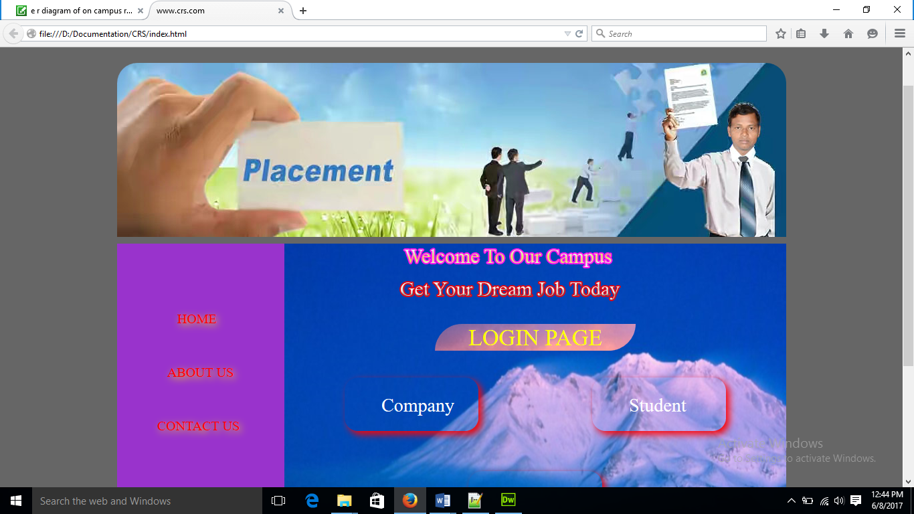

**Company Login**

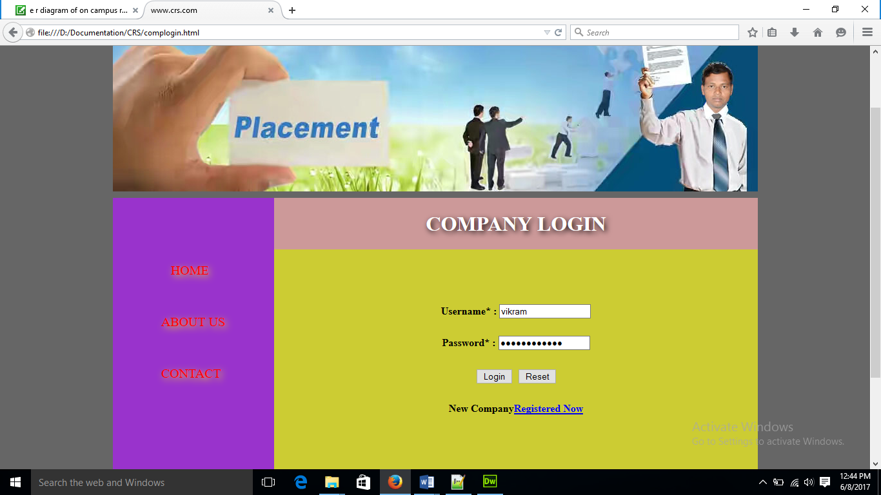

**Student Login**

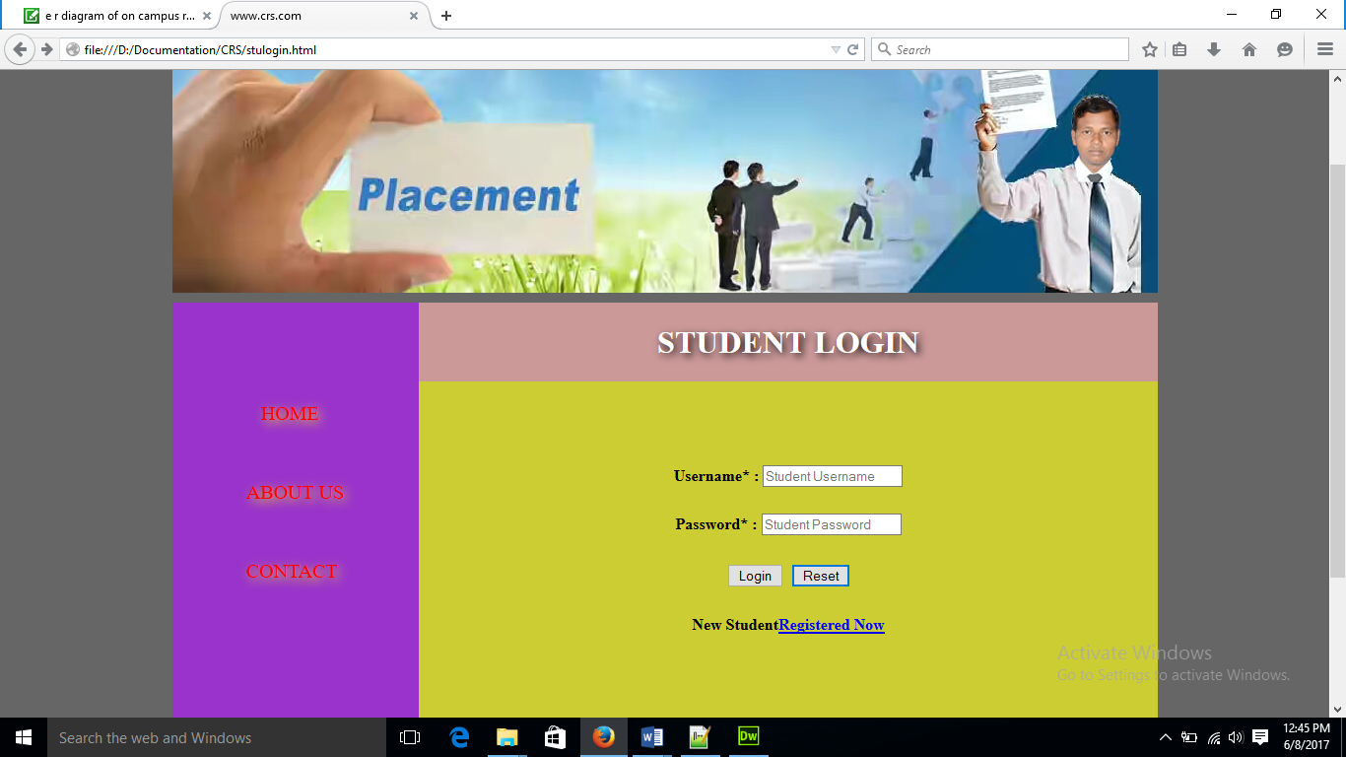

**Admin Login**

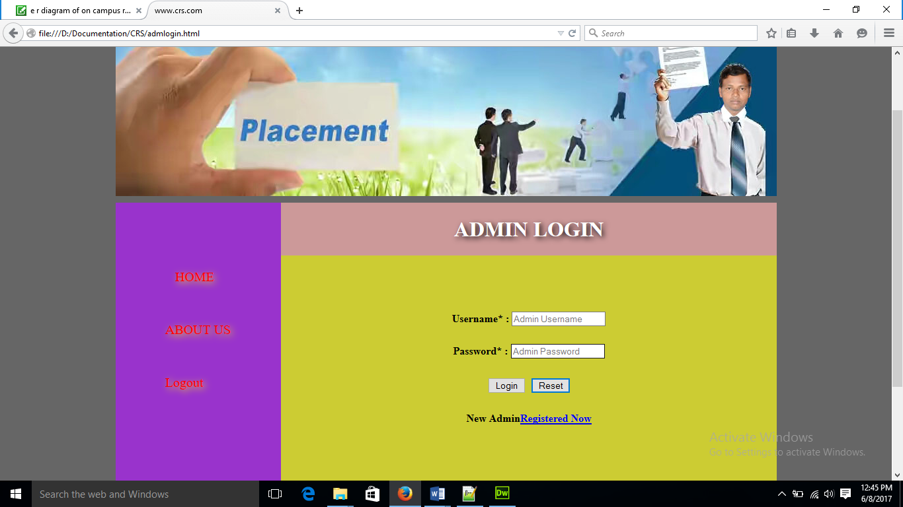

**Company Registration**

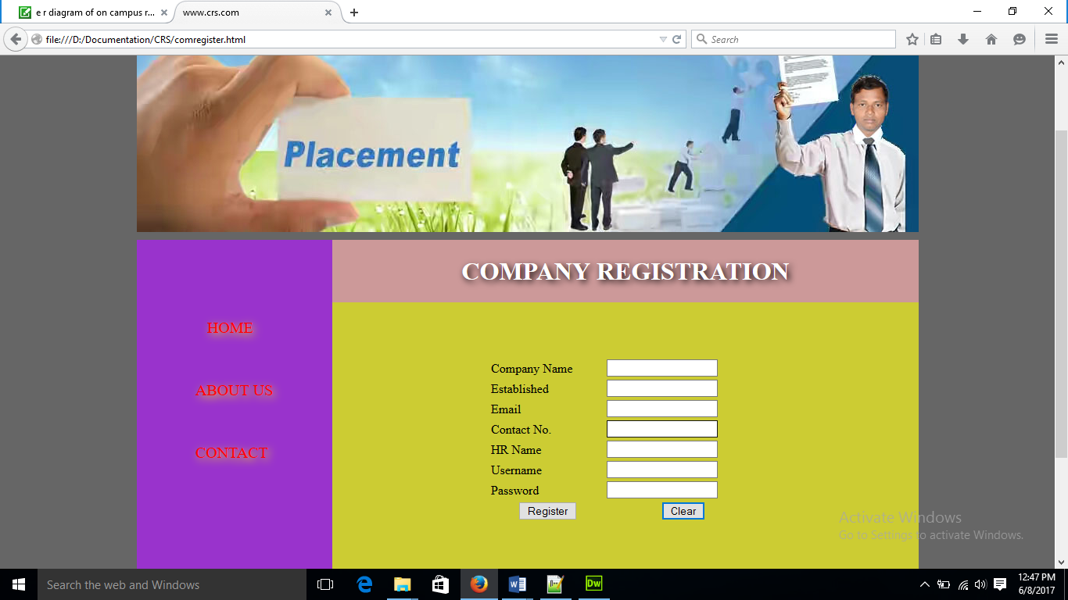

**Student Registration**

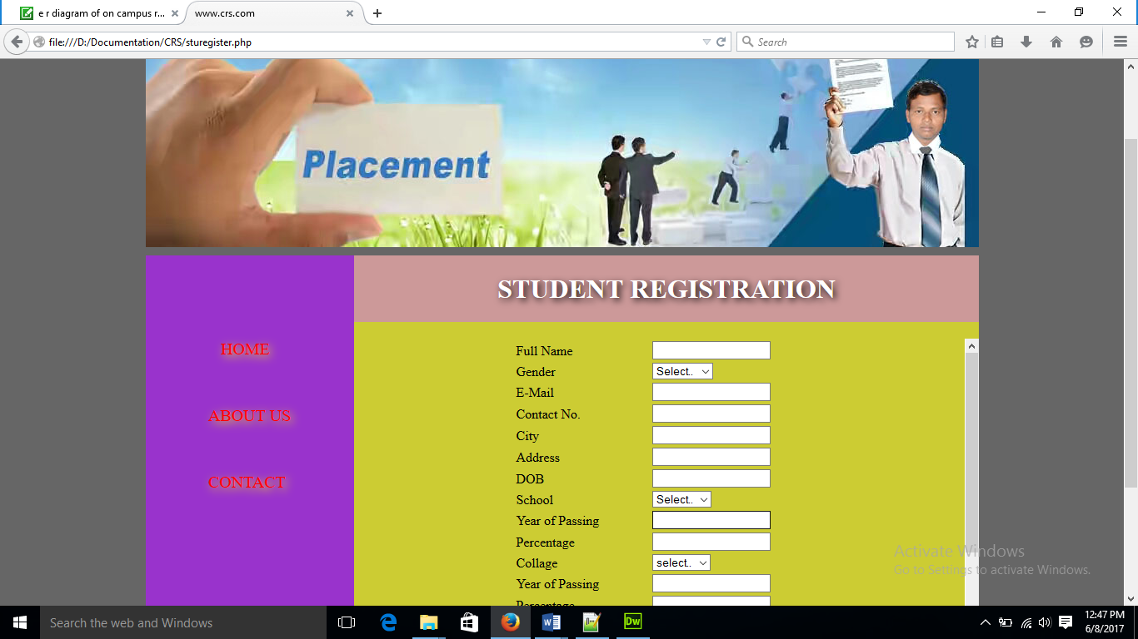

**View Company Detail**

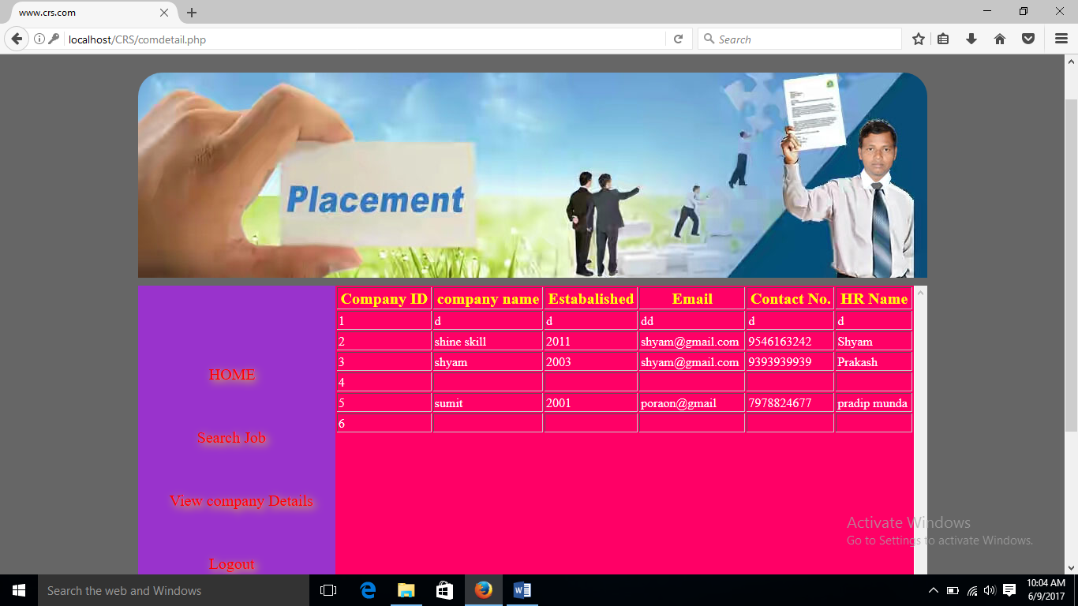

**View Search Job**

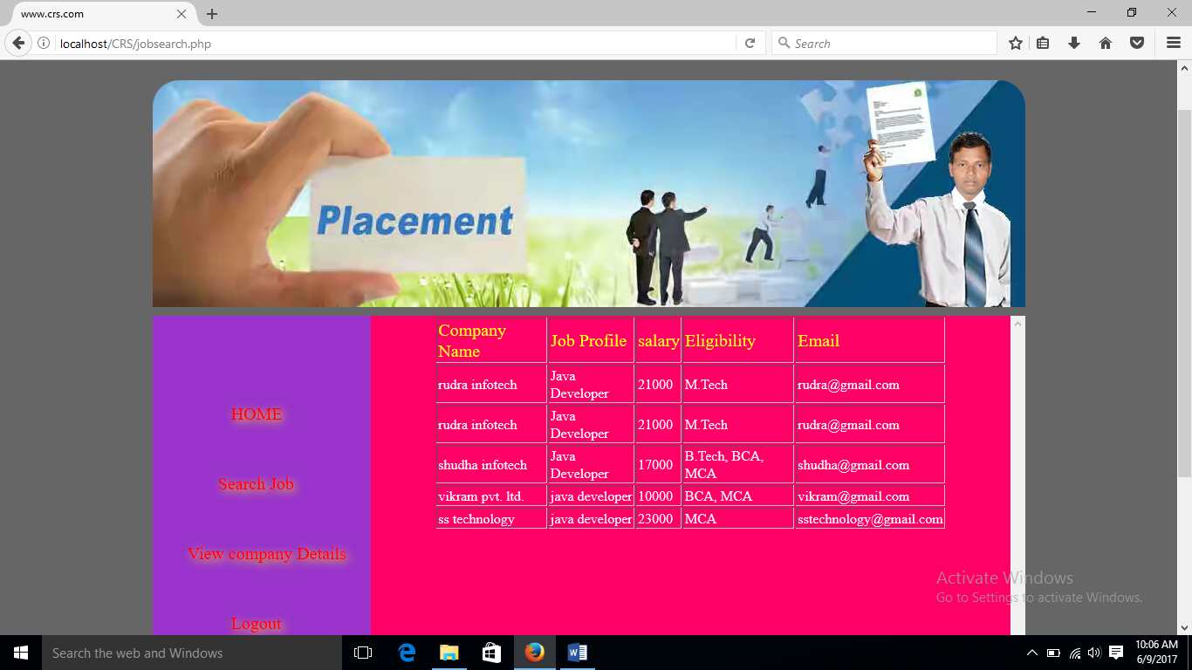

**View Student Detail**

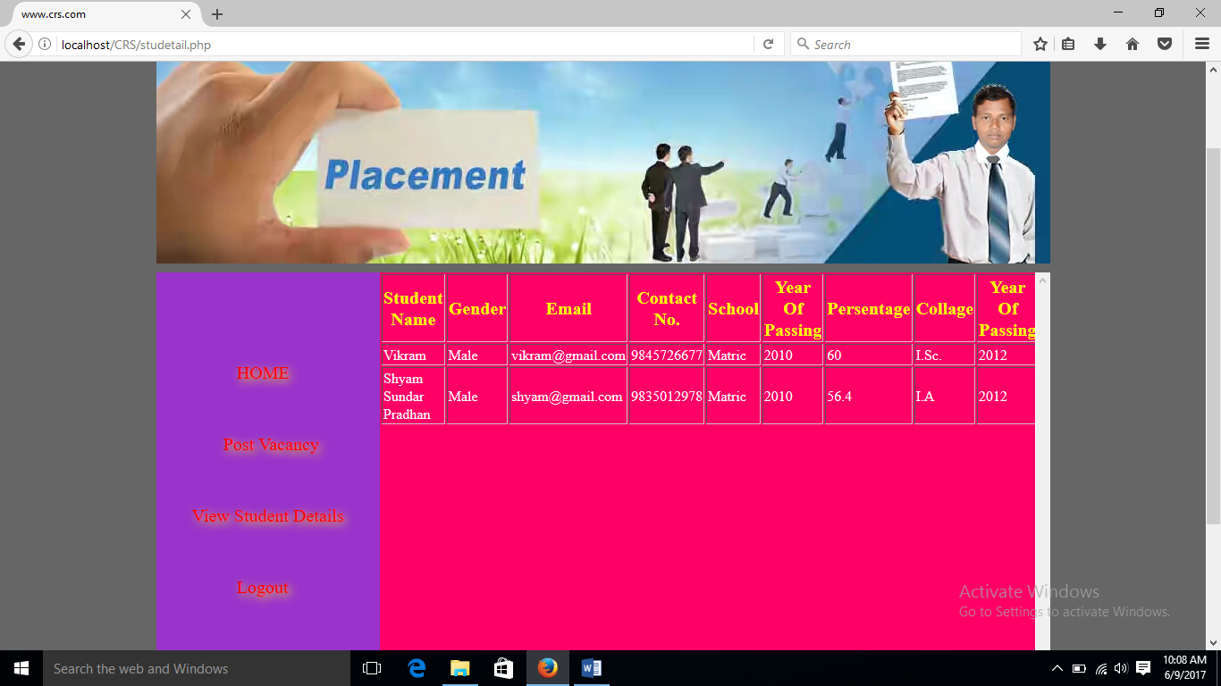

**Post Vacancy**

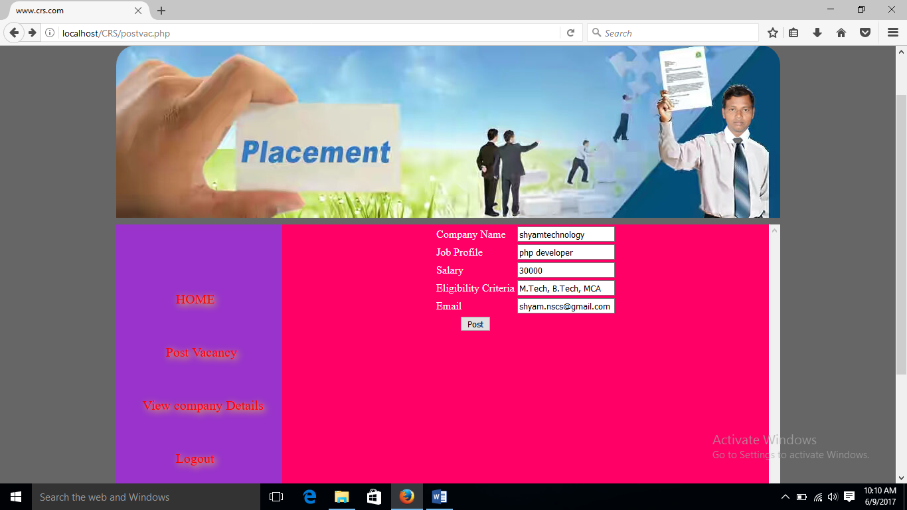

**CHAPTER-6**

**CONCLUSION**

**6.1 Conclusion**

The project Campus Recruitment System (CRS) is for computerizing the working in a Campus. The software takes care of all the requirements of an average Campus and is capable to provide easy and effective storage of information related to company that come up to the campus.

**6.2 Limitation of the system**

* Student can't edit their application once sent. It would require admin to change the data.
* It requires large database.